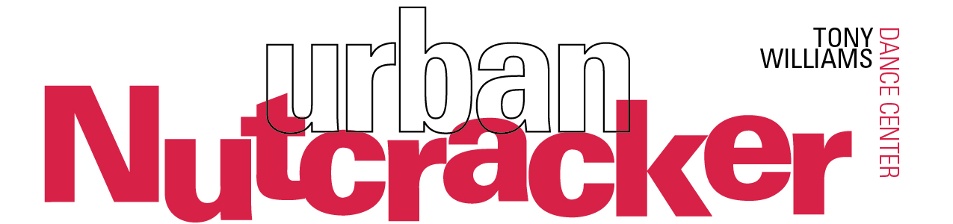

For immediate release
Press Contact: Stephanie Janes, (617) 419-0445, stephanie@stephaniejanespr.com
URBAN NUTCRACKER TO HOST AUTISM-FRIENDLY SHOW
Beloved Boston Show to Produce Sensory-Friendly Performance
Download Production Photos

The Urban Nutcracker is delighted to announce its third annual Autism-Friendly performance on Saturday, December 17 at 11:00AM at John Hancock Hall (180 Berkeley St, Boston, MA 02116).

Russ Kenn, Executive Director of New England Autism Speaks, says, “Thank you so much to our friends at Urban Nutcracker for producing this one of a kind performance! The best present anyone can receive during the holiday season is to be included and valued, and we’re proud to support the efforts the Urban Nutcracker is making towards making this a reality for hundreds of local children and families.” This special performance features dimmed stage lights, slightly brighter house lights, lower music volume, no strobe lighting, a safe space, extra volunteers on-site, and all are encouraged to sing, shout, and dance.

One mother who attended last year’s show said, “From the moment we arrived at the theatre, the caring staff and artists made us feel comfortable, safe and welcome. It was an amazing experience to watch Daniel’s face light up with joy during the show.”

Ameya Kothandaraman, who is playing the role of Clarice this year, says, “Being a part of the autism-friendly show makes me feel really nice inside, because we are doing something for people who don’t get as much attention in theatre. Speaking with some of the audience after the show makes me appreciate that music and dance is really for everyone to enjoy, regardless of how they enjoy it!”

“The highlight of last year’s Urban Nutcracker performances was the Autism-Friendly show we produced,” said Tony Williams, Artistic Director. “We created this show to encourage even more accessibility to the arts, and it was very touching to see such an energetic and appreciative audience, and I am greatly looking forward to it again this year. I’d like to thank all the wonderful Autism advocacy groups out there for the tireless work they do.”

In 2001, local dance legend Tony Williams reimagined the classic holiday Nutcracker tale to become a Boston inner-city story with a neon-buzz, blending the rhythms of Duke Ellington with the classical music of Tchaikovsky. Annually, 150 performers – including professional ballet dancers – take the stage to showcase a broad diversity of dance forms starring the multicultural icons of Boston. Audiences will join heroine Clarice as she explores iconic Boston scenes such as Make Way for Ducklings, Top of the Hub, Chinatown, and the Boston Public Garden. The delightful story continues by following the magical journey of Clarice and her Nutcracker guide through classical ballet, tap, hip hop, jazz, flamenco, and more.
This season’s production includes the new sets and costumes originally designed for the 2015 “15th Anniversary” season of Urban Nutcracker. The stage comes alive with over 85 colorful costumes reimagined by local artist Dustin Todd Rennells (originally designed by Rebecca Cross) and made by hand in Boston, India, Russia, and China. The eye-catching sets by Janie Howland feature popular Boston landmarks like the Fenway Park scoreboard, the Citgo sign, and Downtown Boston.
All performances of the Urban Nutcracker will take place at John Hancock Hall
180 Berkeley St, Boston, MA 02116
Dec 16 | 7:30 PM | Dec 24 | 11 AM
Dec 17 | 11 AM (Autism Sensory Friendly) | Dec 24 | 3 PM
Dec 17 | 3 PM | Dec 29 | 7:30 PM (LGBT Inclusive)
Dec 18 | 11 AM | Dec 30 | 1:30 PM
Dec 18 | 3 PM | Dec 30 | 7:30 PM
Dec 22 | 7:30 PM | Dec 31 | 3 PM
Dec 23 | 7:30 PM

All performances are approximately 2 hours and 15 minutes with one intermission.
Ticket Prices: $25-$85; Discounts for groups of 15 or more
MBTA: Green Line to Arlington, Orange Line to Back Bay
More info: urbannutcracker.com, 888-596-1027
About Urban Nutcracker
The Urban Nutcracker celebrates multicultural Boston through a broad range of diverse dance styles. Produced by the Tony Williams Dance Center, the Urban Nutcracker harnesses the power the arts to unite diverse communities to be a catalyst for positive social change.
Presenting sponsor of Urban Nutcracker is Adage Capital. Additional support is provided by Chobee Hoy Real Estate.
About Tony Williams
Tony Williams is a dance pioneer and retired international ballet star. Williams’ dance philosophy uses the arts to unite diverse communities in Boston, having had direct experience on how transformative the arts can be on young lives. As a young man, he gained access to Boston Ballet’s dance program and progressed to become their first African-American principal dancer. From there he danced with the Joffery Ballet, Royal Winnipeg Ballet, and performed all over the world. When Williams retired, he returned to Jamaica Plain, where it all began, and opened a dance school. Not long after, he produced the beloved Urban Nutcracker which annually enjoys a successful run downtown. Widely respected as a progressive dance educator, Williams has won the Dance Teacher Magazine Award and Wheelock Family Theater’s Wheel Award. In 2014, he founded the Tony Williams Ballet and expanded his dance school to Concord, MA.
urbannutcracker.com
facebook.com/urbannutcracker
@twdancecenter
###

