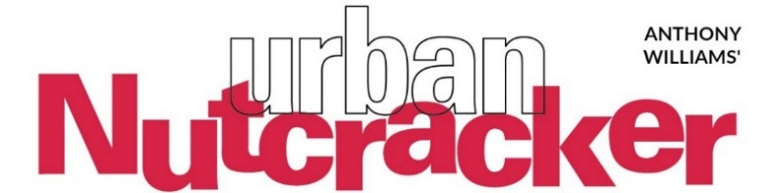
Urban Nutcracker to Stream Online
This Holiday Season
The buzzy Boston production brings diverse dance styles to the streaming stage with everything from ballet, to hip-hop, to tap, and more. All set to music by
Pyotr Ilyich Tchaikovsky and Duke Ellington
Download Photos
Anthony Williams’ Urban Nutcracker, the modern Boston-centric holiday classic produced by City Ballet of Boston, moves online for 2020. Special this year, Urban Nutcracker offers a stream of the recording of their 2019 production to audiences!
A true Boston story, local dance legend Tony Williams reimagined the classic holiday tale to become a Boston inner-city story with a neon-buzz, blending the rhythms of Duke Ellington with the classical music of Tchaikovsky.

The streaming performances, November 28—December 24, 2020, showcase winter scenes set in present-day downtown Boston, blending the rhythms of Duke Ellington with the classical music of Tchaikovsky. Anchored by classical ballet, the performances also include a broad range of dance forms such as tap, hip-hop, flamenco, and jazz, accompanied by a small orchestra of local musicians.

More than 150 performers – local children and professional ballet dancers – take the streaming stage in this joyful rendition of heroine Ruby’s adventure with the street magician Drosselmeyer as they explore iconic Boston scenes such as Make Way for Ducklings statues, the golden dome of the State House, and the Boston Public Garden. Fun for boys and girls alike, the Urban Nutcracker can be enjoyed by the whole family, and all ages!
Tony Williams says, “The magic of our Urban Nutcracker production can be shared with family and friends near and far this holiday season! The success of our production with audiences through the years is due, in part, to the blending of Tchaikovsky's eternally classic music with Duke Ellington's jazz arrangements of the score.”
Dates and times of Anthony Williams' Urban Nutcracker streams in 2020:
Saturday, November 28, 2020 at 7pm
Friday, December 4, 2020 at 7pm
Sunday, December 13, 2020 at 2pm
Thursday, December 24, 2020 at 7pm

Ticket details TBA
More information will be available at http://urbannutcracker.com/
Due to Covid-19's unparalleled impact on presenting live theater, City Ballet of Boston will not be able to celebrate the planned 20th anniversary of the “Urban Nutcracker.” This trend-setting holiday classic with an inner-city twist will celebrate its official 20th anniversary in 2021 at the Boch Center Shubert Theatre.

About City Ballet Boston

City Ballet of Boston (CBB) is a non-profit 501(c)(3) organization that provides quality dance training to a diverse urban community allowing it to run an elite professional company. The company is built on a robust values system of inclusiveness and believes that diversity through dance heightens creativity both in the studio and on the stage. The core philosophy of a rigorous dance curriculum is that quality dance builds physical and mental discipline and is also an excellent means of cultural education.

CBB has in place a rich training program to deliver a quality dance education, focused primarily on ballet, in a comprehensively supportive environment. The training provided goes beyond dance, and students will receive support and guidance to develop better connections with each other and their communities. This is a significant step in achieving the ultimate goal of creating more professional dancers of color and for these dancers to experience personal growth and development to sustain them through their careers and beyond.

The company offers two scholarship programs for young dancers: Relevé (Trainees, ages 8-12) and Boston City Youth Ballet (Apprentices, ages 3-18). The programs, now in their second year, are funded in part by Carl & Ruth Shapiro Family Foundation.

To donate to City Ballet Boston, visit: cityballetofboston.org

About Urban Nutcracker and Tony Williams
The Urban Nutcracker celebrates multicultural Boston through a broad range of diverse dance styles. Urban Nutcracker harnesses the power the arts to unite diverse communities to be a catalyst for positive social change. Presenting sponsor of Urban Nutcracker is Adage Capital.
Tony Williams is a dance pioneer and retired international ballet star. Williams’ dance philosophy uses the arts to unite diverse communities in Boston, having had direct experience on how transformative the arts can be on young lives. As a young man, he gained access to Boston Ballet’s dance program and progressed to become a principal dancer. From there he danced with the Joffery Ballet, Royal Winnipeg Ballet, and performed all over the world. When Williams retired, he returned to his hometown of Jamaica Plain, where it all began, and opened a dance school. Not long after, he created the beloved Urban Nutcracker which annually enjoys a successful run in downtown Boston. Widely respected as a progressive dance educator, Williams has won the 2019 Boston Dance Alliance Dance Champion Award, the 2011 Dance Teacher Magazine Award, and the 2008 Wheelock Family Theater’s Wheel Award alongside Jacques D'Amboise.
urbannutcracker.com
facebook.com/urbannutcracker
Instagram @urbannutcracker

Press Contact for Urban Nutcracker: Stephanie Janes, 617-419-0445, stephanie@stephaniejanespr.com

