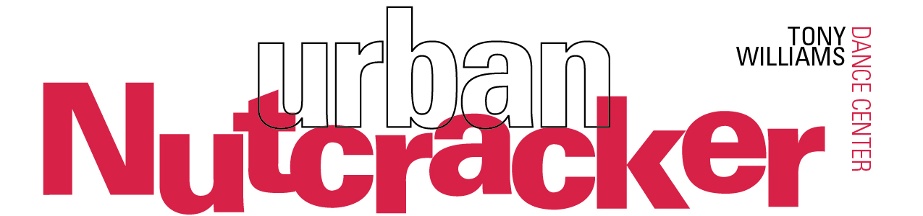
For immediate release
Press Contact: Stephanie Janes, 617-419-0445, stephanie@stephaniejanespr.com
Urban Nutcracker, Delighting Audiences of All Ages, Returns for its 17th Year
Boston’s Most Diverse, Inclusive, and Fun Holiday Production!
Download Photos

Tony Williams Dance Center presents the 17th year of the Boston holiday classic, Anthony Williams’ Urban Nutcracker, December 15-28 at John Hancock Hall (180 Berkeley St, Boston, MA 02116). This modern holiday classic has been praised as “a Nutcracker with real soul” by Boston Metro and “Greater Boston’s most diverse re-imagining of the E.T.A. Hoffmann tale” by The Boston Globe. This year includes a special Autism sensory-friendly performance, now an annual tradition, on Dec. 27.

In 2001, local dance legend Tony Williams re-imagined the classic holiday Nutcracker tale to become a Boston inner-city story with a neon-buzz, blending the rhythms of Duke Ellington with the classical music of Tchaikovsky. Annually, 150 performers – including professional ballet dancers – take the stage to showcase a broad diversity of dance forms starring the multicultural icons of Boston. Audiences will join heroine Clarice as she explores iconic Boston scenes such as Make Way for Ducklings, Top of the Hub, Chinatown, and the Boston Public Garden.

The delightful story continues by following the magical journey of Clarice and her Nutcracker guide through classical ballet, tap, hip hop, jazz, flamenco, and more. Fun for boys and girls alike, the Urban Nutcracker can be enjoyed by the whole family, and all ages!
The performances this year have several surprises in store for the audience:
Dorchester native, dancer Sean Fiedler of Broadway’s Bring in 'da Noise, Bring in 'da Funk, will return to the Urban Nutcracker, his first performance with the company since 2012. Sean started dancing at the age of 3 at the Roxbury Center for the Performing Arts. He was featured in Missy Elliot’s video The Rain and was selected for the national tour of Savion Glover’s Tony Award winning show Bring in Da Noise Bring in Da Funk.
Urban Nutcracker will also honor the iconic story of Make Way For Ducklings, written and illustrated in 1941 by Robert McCloskey. The production will partner with the Boston Police Department to invite an officer to play the role of “Officer Michael” at each performance. Representing a variety of neighborhoods and towns within Greater Boston, “Officer Michael” will lead the ducks, dancers ages 7-10, in their procession across the stage.
Russian ballerina Kseniya Melyukhina will dance the role of the Sugar Plum Fairy, and former Boston Ballet and Dance Theatre of Harlem dancer, Erika Lambe, will play Clarice’s mother.
Other production delights include the ‘50’s Doo-Wop group the G-Clefs and the Flamenco Dance project led by Sabrina Aviles. Dancer/choreographers Gino DiMarco and Brian Washburn are re-imagining Clarice’s dream Battle Scene with a mix of hip-hop and balletic pointe work.

Tony Williams says of this year’s production, “I am so pleased to be presenting the Urban Nutcracker for the 17th year. It is very rewarding to have the Urban Nutcracker be accepted by the Greater Boston community and be known as an enduring holiday classic. It became clear that this production embraced multi-culturalism and represented a more inclusive holiday tradition. Our production draws in so many Boston influences and backdrops, it is really a show I created to honor Boston and our history.”
This season’s production includes the new sets and costumes originally designed for the 2015
“15th Anniversary” season of Urban Nutcracker. The stage comes alive with over 120 colorful costumes re-imagined by local artist Dustin Todd Rennells (originally designed by Rebecca Cross) and made by hand in Boston, India, and Russia. The dazzling costumes of the Sugar Plum Fairy and Snow Queen were hand-beaded with over 450 Swarovski crystals on each costume.
The eye-catching sets by Janie Howland feature popular Boston landmarks like the Fenway Park scoreboard, the Citgo sign, and Downtown Boston. Of the sets, Howland says, “The redesigned sets for the Urban Nutcracker reflect the diversity of Boston’s neighborhoods and our place in the global community. Projections are used in Act II to add a fantastical element to the dream sequence and support the different nationalities represented in the dances. We are constantly upgrading the design to add some new surprises for the audiences.”

“Hip-hop holiday fun… [with] enthusiasm and a sense of inclusive community onstage.”
-The Boston Globe

“[Urban Nutcracker] continues to defy tradition while solidifying itself as a local holiday icon…You'll find a menagerie of bright colors, modern dance, and a swinging score.”
- WGBH, Open Studio with Jared Bowen

“A modern take on the classic 19th century ballet.”
- NBC Boston
All performances of the Urban Nutcracker will take place at John Hancock Hall 180 Berkeley St, Boston:
12/15 | 7:30pm, Opening Night | 12/24 | 1:00pm
12/16 | 11:00am and 3:00pm | 12/26 | 7:30pm
12/17 | 1:00pm and 5:00pm | 12/27 | 7:30pm (Autism Sensory Friendly)
12/22 | 7:30pm | 12/28 | 7:30pm
12/23 | 11:00am and 3:00pm
All performances are approximately 2 hours and 15 minutes with one intermission.
Ticket Prices: $25-$85 | urbannutcracker.com | 888-596-1027 | Discounts for groups of 15 or more
MBTA: Green Line to Arlington, Orange Line to Back Bay
About Urban Nutcracker and Tony Williams
The Urban Nutcracker celebrates multicultural Boston through a broad range of diverse dance styles. Produced by the Tony Williams Dance Center, the Urban Nutcracker harnesses the power the arts to unite diverse communities to be a catalyst for positive social change. Presenting sponsor of Urban Nutcracker is Adage Capital. Additional support is provided by Chobee Hoy Real Estate.
Tony Williams is a dance pioneer and retired international ballet star. Williams’ dance philosophy uses the arts to unite diverse communities in Boston, having had direct experience on how transformative the arts can be on young lives. As a young man, he gained access to Boston Ballet’s dance program and progressed to become a principal dancer. From there he danced with the Joffery Ballet, Royal Winnipeg Ballet, and performed all over the world. When Williams retired, he returned to Jamaica Plain, where it all began, and opened a dance school. Not long after, he produced the beloved Urban Nutcracker which annually enjoys a successful run downtown. Widely respected as a progressive dance educator, Williams has won the Dance Teacher Magazine Award and Wheelock Family Theater’s Wheel Award. In 2014, he founded the Tony Williams Ballet and expanded his dance school to Concord, MA.
###

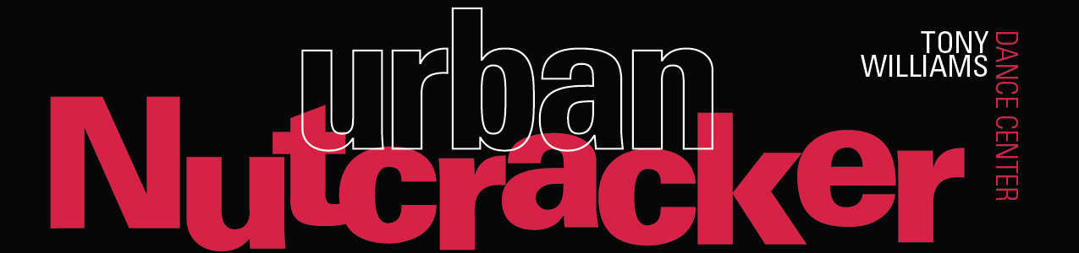
Urban Nutcracker Facts
Since 2001, Urban Nutcracker has been delighting audiences of all ages. Below, you’ll find some interesting facts and figures about Boston’s most unique family holiday experience!
Interesting Production Facts:
- Instead of Clara, the main heroine in Urban Nutcracker is named Clarice, and her brother is Omar instead of Fritz.
- Urban Nutcracker is committed to their motto, “Diversity Through Dance.” Tony Williams, the founder of the Tony Williams Dance Center and the choreographer of Urban Nutcracker, was Boston Ballet's first African-American principal dancer. Making sure dancers of any background have access to dance education is one of Tony's most important priorities.
- Many of the street scenes are classically "Boston," with scenes from Make Way for Ducklings, the iconic Citgo sign, Chinatown, the Top of the Hub, and the Boston Public Garden.
- The music is not just Tchaikovsky...Tony Williams also weaves in jazzy Duke Ellington tunes,
Doo Wop, and hip hop.
- This year the performances run Dec 15-28 and include an Autism Sensory Friendly performance on Dec. 27. The show will be tailored to be sensory friendly in order for maximum audience comfort that will feature house lights at half capacity, sounds lower in volume/intensity, volunteers to provide support, and a quiet area. And the audience will be encouraged to dance, sing, and shout!
- Our sets and lights were featured by the RoseBrand theatrical catalog company for our groundbreaking use of projection on nylon string curtains honoring set designer Janie Howland and lighting designer Scott Clyve.
- Each year nearly 25% of the show is re-choreographed to keep the story and the tone fresh. If you haven’t seen it lately, much will be brand new!
- It’s all related: Nearly 25% of our children’s cast is a brother or sister of another dancer! There are five brother/sister teams in our youth cast!
- The Tony Williams Ballet Company (adults & youth) is the primary casting pool for dancers, but we also have dancers from the South Shore, New Hampshire, and around the Boston metro area.
- Our entire show is choreographed and rehearsed in a 41 x 30 foot dance studio in Jamaica Plain.
- Our snow scene releases nearly 20 quarts of paper snow onto the stage at each performance!
- Adam Miller and Leslie Woodies join our team as Associate Artistic Advisors. Adam is formerly of Cirque du Soleil (Kooza and Saltimbanco), Pacific Northwest Ballet, Pennsylvania Ballet, Garden State Ballet, and was a former Director of Jacob’s Pillow Ballet Project. Leslie is a former soloist with Boston Ballet who has received DramaLogue, Robby and IRNE nominations, in addition to being a lecturer at Harvard University and a faculty member of the Boston Conservatory.
Costume Facts
- There are 120 complete costumes in Urban Nutcracker with over 1,400 individual costume pieces
- There are 125 head pieces in the production
- Dancers use over 300 pointe shoes throughout the three weeks of performances
- Over 250 pairs of dance tights are used
- The elaborate beading on the Sugar Plum Fairy and Snow Queen costumes is un-beaded and
re-beaded by hand for each cleaning post-performance. Eight skilled, volunteer parents painstakingly sew these beads on and off daily. The Snow Queen costume has over 5,000 Swarovski crystals set on panels for easier removal
- While most of the costumes were hand-made in Boston, the Act II costumes were created by hand in India and Russia (scenes from the show)
- The Russian costumes are based exactly on traditional Ballets Russe costumes from the turn of the century. The Chinese costumes are a modern cross between Chinese and Indian modern designs
- Every costume is hand washed between each performance
- Each Snow corps costume has 750 Swarovski crystals. There are 8 of these costumes on rotation for 6 dancers
- The set of the Nutcracker/Rat fight scene is designed to reveal hidden black light details
- There are 24 people on the costume staff. They are all volunteers except one, Dustin Todd Rennells, who re-imagined the costumes in 2015

urbannutcracker.com
facebook.com/urbannutcracker
@twdancecenter

